PH115 Lab 2: Measuring Density

Background

All matter has mass and volume. Mass is a measure of the amount of matter an object has. Its measure is usually given in grams (g) or kilograms (kg). Volume is the amount of space an object occupies. There are numerous units for volume including liters (l), meters cubed (m³), and gallons (gal).

Mass and volume are physical properties of matter and may vary with different objects. For example, it is possible for two pieces of metal to be made out of the same material yet for one piece to be bigger than the other. If the first piece of metal is twice as large as the second, then you would expect that this piece is also twice as heavy (or have twice the mass) as the first. If both pieces of metal are made of the same material the ratio of the mass and volume will be the same. However, two different materials of the same volume will generally have different masses.

We define density (ρ) as the ratio of the mass of an object to the volume it occupies. Density is the amount of mass per unit volume a material has and tells you for a given shape and size which material will be ‘heavier.’ The equation is given by:
$ρ=\frac{M}{V}$ (1.1)
here the symbol M stands for the mass of the object, and V the volume. Density has the units of mass divided by volume such as grams per cubic centimeters (g/cm³), kilograms per cubic meter (kg/m³), or kilograms per liter (kg/l). In this lab, we will use grams for mass and cubic centimeters for volume.

Problem #1
A block of wood has a mass of 8 g and occupies a volume of 10 cm³. What is its density?

Activity: Determine the density of an object with a regular shape.

Obtain a set of objects (cube, cylinder, sphere, etc.) made of the same material but with different shapes or sizes. Calculate the density by measuring the mass and volume of your samples.

Measuring the Mass
Measure the mass of your samples using the scale provided. You will make this measurement three times and calculate the average. Record your results in the table below.
Trial | Sample 1 | Sample 2
1
2
3
Avg.

We also need to think about the uncertainty in your measurement. Based on the digits displayed on the scale, what is the most accurate measurement you could make? Is it 1g, 0.1g, or 0.01g, or some other value?

Uncertainty in mass measurement: __________________ (g)

Measuring the Volume
To determine the volume of an object with a regular shape there are standard equations that may be used. The equations for three common shapes are given below.
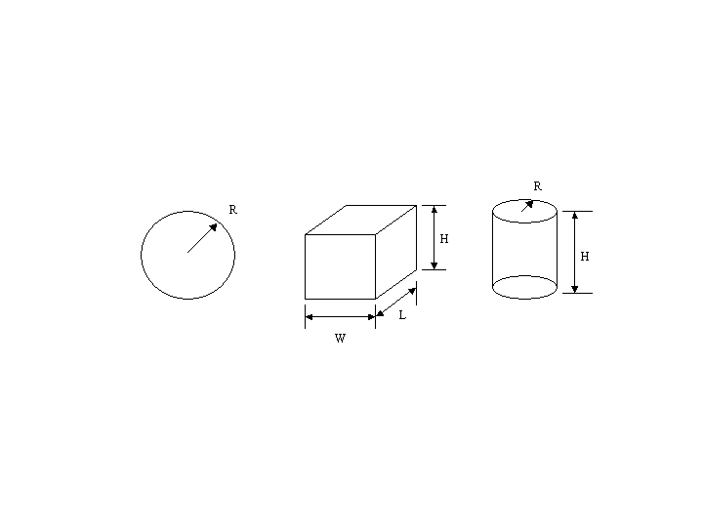
Sphere Cube Cylinder
$V=\frac{4}{3}⋅π⋅R^{3}$ $V=L⋅W⋅H$ $V=\frac{π}{4}⋅R^{2}⋅H$ (1.2)

Measure the relevant dimensions of your sample and record the reading in the tables below.

Sample #1

Trial | Length (cm) | Width (cm) | Height (cm)
1
2
3
Avg.

Calculate the volume of Sample #1 using equations (1.2). Show all work

Volume = ____________________________________________________.

Sample #2
Trial
1
2
3
Avg.

Calculate the volume for Sample #2. Show all work

Volume = ____________________________________________________.

Again, we need to know the uncertainty in each dimension. What is the uncertainty in your measurement of each dimension?

Uncertainty in length measurements: __________________ (cm)

Calculate the Density

Specimen | Volume  (cm³) | Mass  (grams) | Density  (gm/cm³)

Look up a table of densities for pure elements. Based on the density you measured, what material do you likely have? By what percentage does your result differ from the listed value?

Sample Problem #2
A block of wood has a mass of 4 g and occupies a volume of 5 cm³. You know it might be oak, pine, American elm, or magnolia. Based on its density, which type of wood can it be?

Unlike the mass and volume that may be different for each specimen, all objects made of the same material will have the same density. Because of this the density is often used to identify unknown substances or to determine the percent composition.

Determine the density of another material

Now find an object which is clearly made of a different material and repeat the steps above to determine its density. What material is this?

Density: ______________________ Material: _____________________

Estimating your uncertainty

You already know your measurements are imperfect and have an estimate of their uncertainty. How to the uncertainties in the individual measurements combine to determine the uncertainty in your determination of density? You have uncertainties in the lengths and mass, how do you combine them? The simplest, and most conservative estimate of the overall uncertainty would be to add the absolute value of the percent error for each measurement you made. If you have a rectangular object, the volume is L x W x H, so the overall uncertainty in volume would be

(percent error in volume, rectangular solid) = |percent error in L| + |percent error in W| + |percent error in H|

If you have a spherical object, since the volume involves r³, you need to triple the contribution from the radius:

(percent error in volume, sphere) = 3 x |percent error in r|

The percent error is the uncertainty in that measurement divided by the measured value:

(percent error in L) = 100% x (uncertainty in L)/(measured value of L)

For example, if your uncertainty is 0.1cm (1 mm) and you measured 5cm, the percent error is 2%. For one of your objects, calculate the percent error in volume.

Object & material: _______________ Percent error in volume (V):_______________

The density involves both mass and volume. The uncertainty in density therefore involves adding the percent uncertainty from both mass and volume. Find the percentage uncertainty in your mass measurement:

(percent error in M) = 100% x (uncertainty in M)/(measured value of M)

Object & material: _______________ Percent error in mass (M):_______________

Finally, we can add the absolute values of the uncertainties in M and V to estimate the uncertainty in density:

(Percent uncertainty in density) = |percent uncertainty in M| + |percent uncertainty in V|

Your final result for density of this object, including uncertainty, should be reported as
(measured value of density) +/- (percent uncertainty in density)

Object & material: ________________________________

Density (ρ) with uncertainty: ________________________________

For example, 2.75 g/cm³ +/- 5% would indicate you measured a value of 2.75 g/cm³, but it had 10% accuracy, meaning the true result could be anywhere between 2.61 and 2.89 g/cm³, consistent with the accepted value for Aluminum (Al).

Adapted from NASA-GISS https://www.giss.nasa.gov/edu/nycri/units/pmarchase.html

