Kepler’s laws & Orbits
In this activity you will be exploring Kepler’s Laws and Orbital Motion using the “Gravity and Orbits” PhET simulation.
Open the simulation by clicking on the link:
https://phet.colorado.edu/sims/html/gravity-and-orbits/latest/gravity-and-orbits_en.html
Take a look at the explanatory video via YouTube (3m27s):
https://youtu.be/m6e2y4fef1I
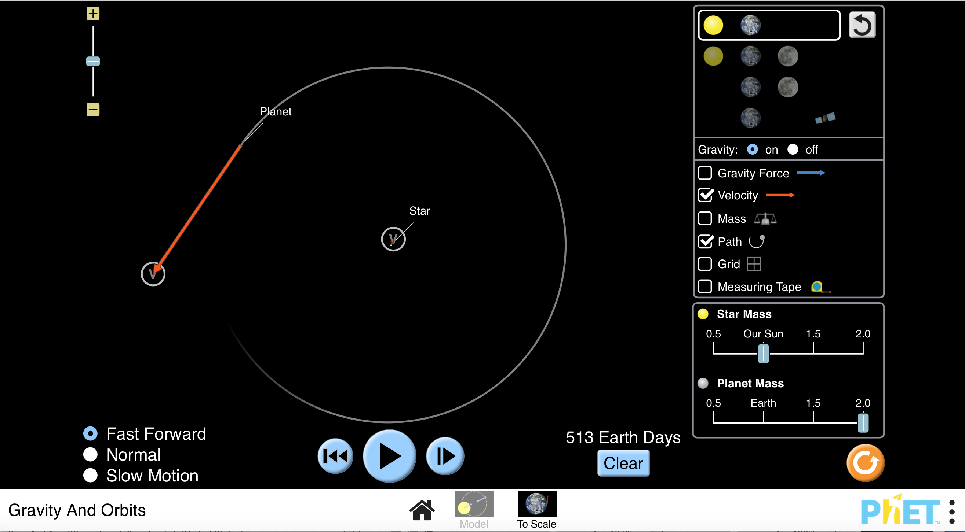
Learning Objectives ____________________________________________________________________________By the end of these activities it is hoped that you will have acquired a better understanding of:
- The shape of planetary orbits and determining factors
- Relate how planetary orbits link to Kepler’s first two laws of planetary motion.

1. Is the orbit of a planet circular?
- Press the TO SCALE option at the bottom of the screen with the star and planet chosen, see opposite image.
- Turn on the path/grid option ON, see green circle.
- Allow the planet to move through 360o.
- Turn on the measuring tape from the tool bar, green circle.
- Measure the horizontal distance from the path line on the left of the star. Write the measurement in the table below.
- Now do the same from the star to the path line on the right hand side.
Distance (miles)
Left side from path to star
Right side from star to path

•

Questions:

- What do you notice about the distances?

- What does this data say about the orbit of the planet? Discuss.

2. Linking planetary orbits to Kepler’s Laws?
- Go to model
- Click sun and planet
- Press PLAY, blue circle (with path/gravity/ velocity/grid ON, green circle) and leave for one cycle then PAUSE.
! Paste screen shot of trajectory here:

Questions:
- What holds the planet in the orbit?

- What shape is the orbit? Use the screenshot to explain this.

- Turn ON gravity force button, green circle above.
Question: What direction do the forces point? Include screenshot as proof.

- Turn the gravity OFF, green circle above.
Question: What happens to the planet & why? Include screenshot this as proof.
Screenshot of the trajectory

t of the direction
- Reset the simulation (Orange button with circular arrow.) Increase slightly the velocity of the plant by extending the red ‘v’ arrow of the planet, green circle.
Questions:
- What happens to the planet in the orbit?

- What is the shape of the orbit when v is increased?

- Reset the simulation again. Now increase the velocity of the plant to a large extent by extending the red ‘v’ arrow.
Question: What happens to the planet in the orbit?

- Reset. Now decrease slightly the velocity of the plant by diminishing the red ‘v’ arrow, green circle.
Questions:
- What happens to the planet in the orbit?

- What is the shape of the orbit when increased?

- Reset. Now decrease the velocity of the plant to a large extent by moving the ‘v’ arrow in.
Questions:
- What happens to the planet in the orbit?

- What would explain this?

- Is the velocity constant throughout the journey?

- Which one of Kepler’s law does this relate to?

- Reset. With the star and planet chosen and path/grid on, increase the mass of the star by sliding the controller to 1.5/1.75/2.0.
- What do you notice about the orbit?

- What happens to the velocity on the path?

- Reset. Now do the same but change the planet’s mass 1.5/1.75/2.0.
• What do you notice about the orbit?

• Why do you think the observation for your previous answer occurs?

Content author: Simon Lees 2017, via https://phet.colorado.edu/en/simulation/gravity-and-orbits

