Name_____________________________________

Phet: Waves On a String

Waves on a String – Simulation

Aim: to observe relationships between frequency, wavelength, speed of waves in a rope, and observe how these change with changing tension in the rope.

Method: Use the pHet app “Wave on a string”
https://phet.colorado.edu/sims/html/wave-on-a-string/latest/wave-on-a-string_en.html

Experiment 1 – Speed of wave and tension
Set to “Pulse”; “Fixed End”; Damping = None; Normal; Tension = Low
Turn the Ruler and Timer on

Use the ruler to measure the length of the piece of string. Record
Click the button on the pulse generator to send a pulse through the string
Use the timer to measure how long it takes for the pulse to travel back and forth 5 times.

Repeat on moderate and High tension

Results:
String length =
Tension | Time for pulse to travel 5 round trips | Time to travel one round trip | Length of one round trip | Speed of wave = length / time
Low
Medium
High

Conclusion:
How does tension affect the speed of a wave in a rope?

Experiment 2 – Generating Standing Waves of Different Harmonics
Set to “Oscillate”; “Fixed End”; Damping = None; Normal; Tension = Medium, Amplitude = 0.20 cm
Turn the Ruler and Timer on

Use the ruler to measure the length of the piece of string. Record it here:

Use the results of Experiment 1 to determine the speed of the wave when the rope is set to medium tension. Record here:

Analysis:
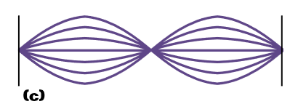
1) Determine the wavelength that will generate a second harmonic standing wave. Record it here:

Use v = λ * f to calculate the frequency of this wave.
Record it here:

Input this frequency into the simulator and press restart. If it works, show your teacher and get it checked off:

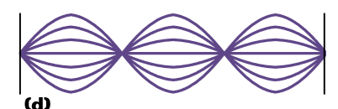
2) Determine the wavelength that will generate a third harmonic standing wave. Record it here:

Use v = λ * f to calculate the frequency of this wave.
Record it here:

Input this frequency into the simulator and press restart. If it works, show your teacher and get it checked off:

3) Draw a picture of a fifth harmonic standing wave:

Determine the wavelength that will generate a fifth
harmonic standing wave.
and Record it here:

Use v = λ * f to calculate the frequency of this wave.
Record it here:

Input this frequency into the simulator and press restart. If it works, show your teacher and get it checked off:

Experiment 3: Relationship between wavelength and frequency

Set to “Oscillate” and “No End”
Keep the ruler and timer on

Set the frequency to 1 and tension to low
Measure the time it takes for a wave to travel the length of the string
Measure the length of a single wave length.

Do the same measurements at Frequency = 2 and 3

Repeat the experiment at moderate and high tension

Results:
Tension | Frequency | Time to travel the length of the string | Wavelength | Speed =  Length/time | Frequency X wavelength
Low | 1
Low | 2
Low | 3
Moderate | 1
Moderate | 2
Moderate | 3
High | 1
High | 2
High | 3

Conclusion:
- If the tension remains constant and the frequency increases, what happens to the wavelength?

- Is there any pattern in the last two columns of the table (speed and Frequency X wavelength)?

- What is the relationship between frequency, wavelength and speed of a wave?

