Hooke’s Law & Springs – PhET Simulation

https://phet.colorado.edu/sims/html/masses-and-springs/latest/masses-and-springs_en.html

Introduction

Hooke’s Law teaches us how springs can store and use potential energy. It is expressed as a ratio of the force needed to stretch a spring and the distance it is stretched:
$$k=\frac{F}{x}$$
Where “k” is the spring’s constant, a value that is the same for the spring no matter how much force is acting on it; “F” is the force used to displace the spring, and “x” is the distance the spring is displaced, in meters. The units for spring constant are N/m.

In this simulation lab, you will calculate the spring constants of three different springs, one with a low spring constant, one with a medium spring constant, and one with a large spring constant. You will then use those spring constants to find the mass of three unknown weights.
Click the link above to open the simulation.

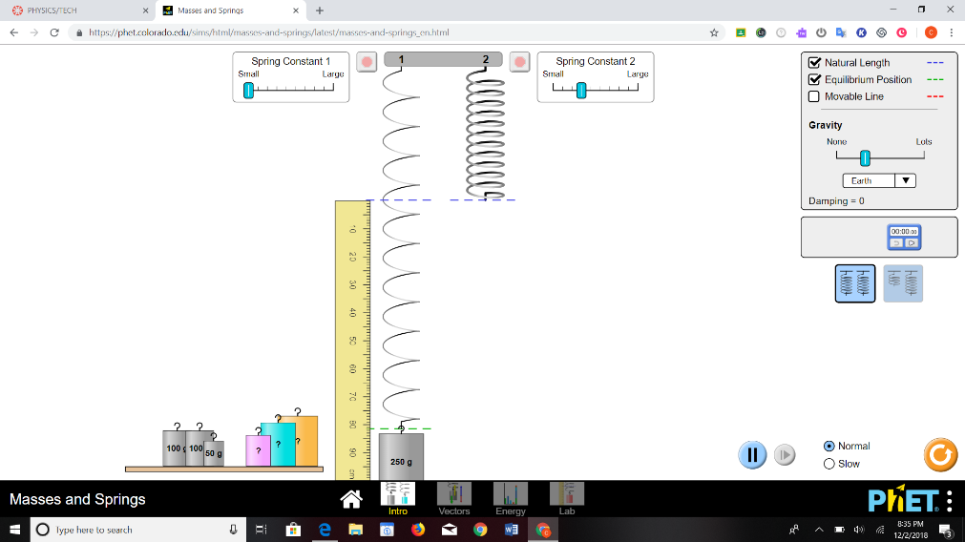

Preliminary Questions
- How can we use a spring to determine an unknown mass?

- Variables:

Independent Variable (the variable in this investigation that is being changed by you): _______________________________________
Dependent Variable (the variable that is observed):
_______________________________________
- What is the relationship between the displacement of a spring and the mass of an object attached?

- You put an object on a spring and then let it bounce up and down. It stops moving after a few minutes.
When did the object have the most potential energy?
a. When it was bouncing.
b. Before it started bouncing.
c. When it stopped bouncing.
d. Both b and c.
- When did the object have kinetic energy?
a. When it was in motion.
b. Before it started bouncing.
c. When it stopped bouncing.
d. None of the above. Kinetic energy remains constant.
- If a spring has an object attached to it on Jupiter, the spring would change shape:
  - more than on Earth.
  - less than on Earth.
  - the opposite direction as on Earth.
  - The spring wouldn’t change shape.

Experiment

- This whole lab can be done from the “Intro” page, so click that. Spend some time playing with the springs and seeing how they work. Clicking “Natural Length”, “Equilibrium Position” and using the ruler can help you find the displacement of the spring.

- When you are ready to begin the lab, turn on the “Natural Length”, “Equilibrium Position” and use the ruler. Start with 50 grams (0.05 kg) and the Spring Constant slid all the way down to small. Use this and your Weight formula to find the force pulling on the spring, and measure how many meters the spring is displaced. Click the Stop Sign at the top to get it to stop oscillating. Remember, divide by 100 to convert cm to m! Add this to your data table below, and use these values to calculate the spring constant. Repeat with 100 g (0.1 kg) and 250g (0.25 kg), and find the average of all the spring constants that you calculated.

Spring Constant set to Small
Mass (kg) | Gravity (g) | Weight/Force (N) | Displacement (m) | Spring Constant (N/m)
0.05 kg
0.1 kg
0.25 kg
 |  |  | Average:

- Repeat the lab with the spring constant set halfway between “Small” and “Large”.

Spring Constant Set Halfway between Small and Large
Mass (kg) | Gravity (g) | Weight/Force (N) | Displacement (m) | Spring Constant (N/m)
0.05 kg
0.1 kg
0.25 kg
 |  |  | Average:

- And repeat once more with the Spring Constant set all the way up to “Large”

Spring Constant Set at Large
Mass (kg) | Gravity (g) | Weight/Force (N) | Displacement (m) | Spring Constant (N/m)
0.05 kg
0.1 kg
0.25 kg
 |  |  | Average:

- Now we’ll find the mass of the three “Mystery Weights” That are provided. Since we now know the spring constant (or at least an average) we can work backwards to find the mass. Rearranging Hooke’s Law, we have:
$$F=kx$$

And using the weight in place of force, we get:

$$W=kx$$
$$mg=kx \\ m=\frac{kx}{g}$$

So we’ll multiply the spring constant you found above by the displacement, then divide that by gravity to get the mass of our “mystery masses”. Fill in the data table below, being careful to use meters and kilograms.

Mass Color | Spring Constant (N/m) | Displacement (m) | Force/Weight (N) | Gravity (g) | Mass (kg)

- Select the words that best fill in the conclusion:
“The larger the Spring Constant, the (Stiffer/ Looser) the spring, and the (More/Less) force is required to get it to be displaced.”

- You probably noticed that the mass exhibits oscillatory motion when placed on the spring.
    - For a given spring constant, does the time it takes to complete one oscillation (the period) increase or decrease as the weight increases?

    - For a given mass, does the period increase or decrease as you increase the spring constant?

    - Can you explain qualitatively why the mass-spring system behaves this way?

- At what point is the potential energy of the system maximum? At what point is the kinetic energy of the system maximum?

